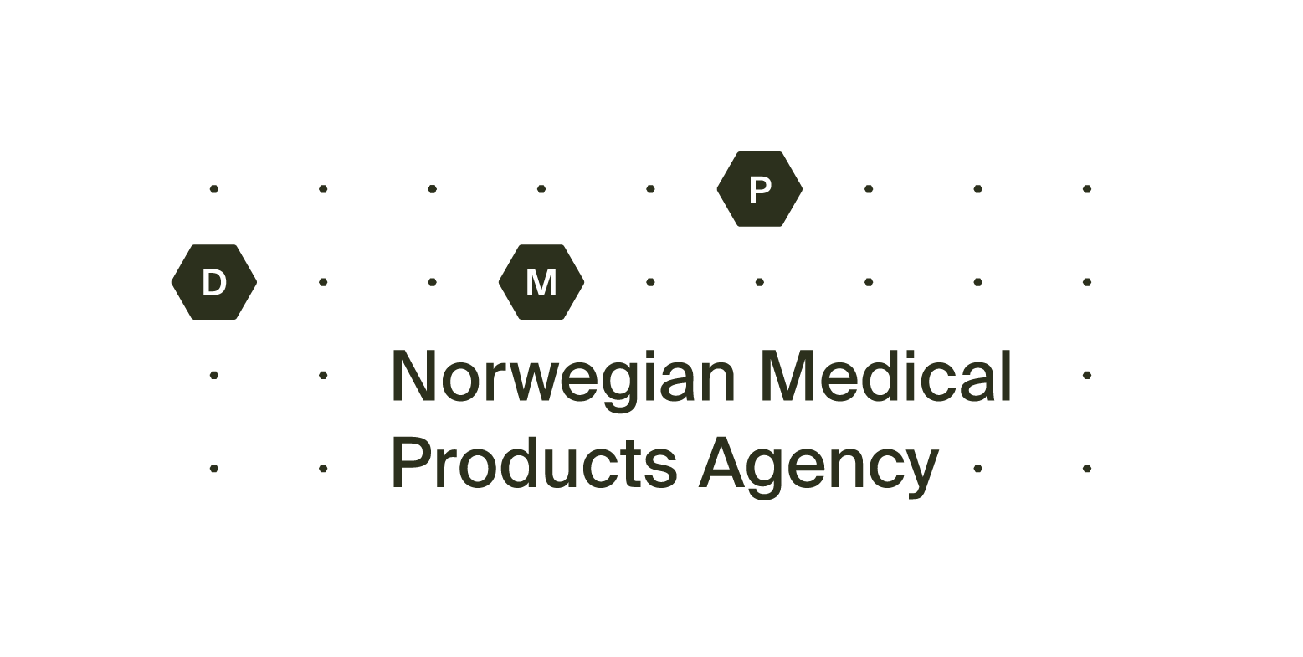Application for marketing authorisation - parallel imported medicinal product

The completed form must be sent to: post@dmp.no.

1. General information about the medicinal product in Norway
1.1. Name under which the medicinal product is to be supplied in Norway:
1.2. Pharmaceutical form:
1.3. Strength:
1.4. Package sizes:

2. Information about the Holder of the Marketing Authorisation for parallel imported medicinal product in Norway
2.1. Company name:
2.2. Address, PO Box, City:
2.3. Country:
2.4. Invoice address:
2.5. E-mail: | 2.6. Phone:

3. Person authorised for communication on behalf of the applicant
3.1. Name:
3.2. Address:
3.3. E-mail: |  | 3.4. Phone:

4. Information about the medicinal product in the exporting state
4.1 Exporting state:
4.2 Name of the product:
4.3 Pharmaceutical form:
4.4 Strength:
4.5 Marketing Authorisation Number in the exporting state:
4.6 Name and address of the Marketing Authorisation Holder in the exporting state; <name>, <city>, <country>:
4.7 Responsible for batch release name and address:
4.8 Legemiddelforskriften (Pharmaceutical regulations) §4-8 b requires a specific claim of notification in order to parallel import patent protected medicines from some countries in EU. See Patentforskriften (Patent regulations) av 20. desember 1996 nr. 1162 § 109a.
Yes, notification has been submitted at least 1 month before this application is being sent. Documentation is enclosed.
No, notification has not been submitted because the medicinal product is not underlied patent protection in the exporting state.

5. Information about the directly imported product
5.1 Name of the product:
5.2 Pharmaceutical form:
5.3 Strenght:
5.4 Marketing Authorisation Number: | 5.5 Legal status:
5.6 Name and address of the Marketing Authorisation Holder; <name>, <city>, <country>:

6. Information about the relabelling/repackaging procedure
6.1 A detailed description of the relabelling/repackaging procedure:
6.2 Package size(s), please clarify if legal status is CF.
Legal status F:
Legal status C:
6.3 Company name:
6.4. Address:
Verification of manufacturing licence is attached

7. Describe the differences between the directly and the parallel imported product
7.1 Describe the main differences in labelling, packaging,colour, break-mark, apperarance and size:

8. Attachment
Scan and/or foto of packaging, outer ,immediate, blister,strips, small immediate and the medicinal product
Drafts of label on the immediate container of the product
Drafts of label on the outer container or carton
Draft of package leaflet

9. Signature by applicant (Responsible person)
Date: | Signature by applicant:

